Marine Biology Practicum Midterm Assessment
Written Portion
- Identify the three species below. (latin name gets extra credit). Hint: A is larger than B. (3)
Identify each as alga or vascular plants? (3)
Consider the following situation: A grass flat is disturbed and substrate is removed (e.g. hole dug by propeller burn or hurricane waves erode substrate). Which species will be the first to colonize the disturbed area? In other words, these three species commonly undergo a specific ecological succession. Which is the first in the succession? (1)
Answer below diagram:
Name up to 5 important ecological roles of this group as a whole. (5)

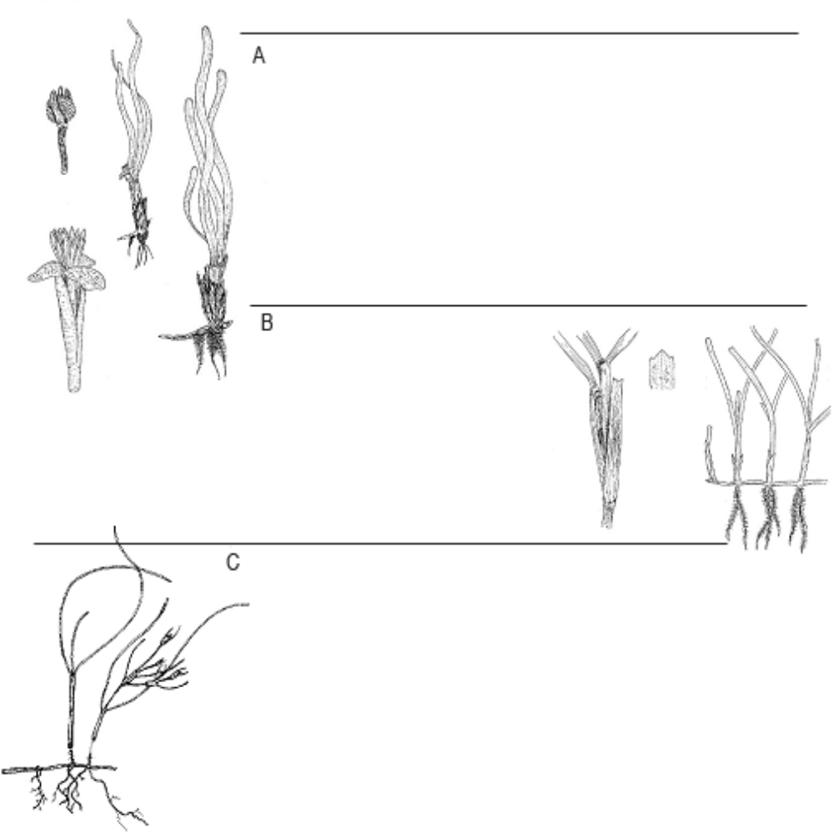
- Identify these three mangroves (if the drawings are not descriptive enough for you look at the “ground” they are growing out of) (3).
